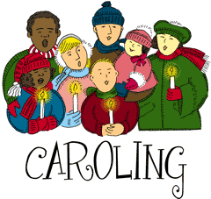
Christmas Carol-Oke
Information Form
Name: ____________________________________________
Address: __________________________ City: _____________Zip: ___________
Video Description: __________________________________________
_______________________________________________________

Rules for the Christmas Carol-Oke:
- Please fill out the form completely. Missing information on the form will result in the registration being incomplete and video unable to be posted.
- Pick your favorite Christmas Carol and combine it with your own version of Karaoke. Video yourself, your children or your family and send the Carol-Oke to us at the Watseka Park District (watsekaparks@att.net).
- We will post these just for fun videos on our website, Facebook and sign.
- Please make sure your Carol-Oke is appropriate for the season and is viewable by all ages.
- Have some Holiday fun and share it with others!

